Dimension Based Calculation Views:

1. Material Master

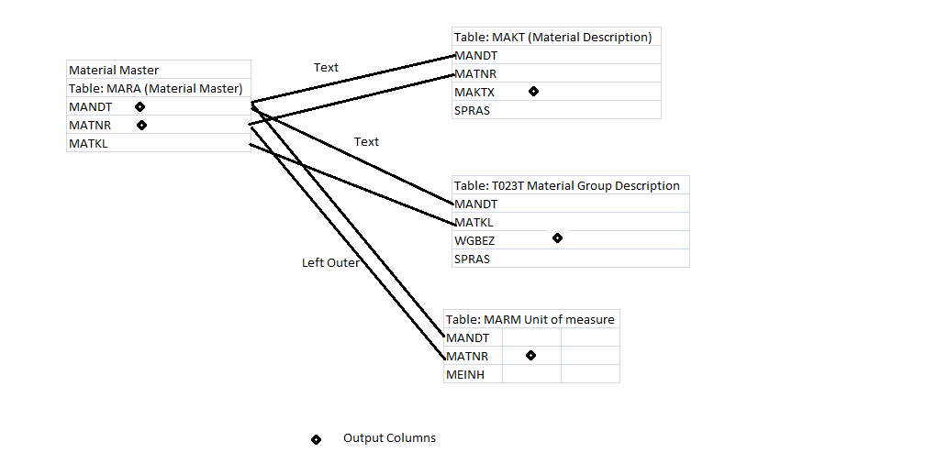

2. Company Code Master

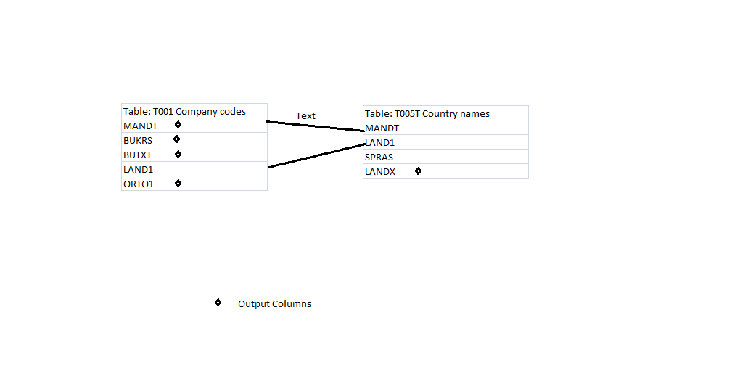

3. Vendor Master

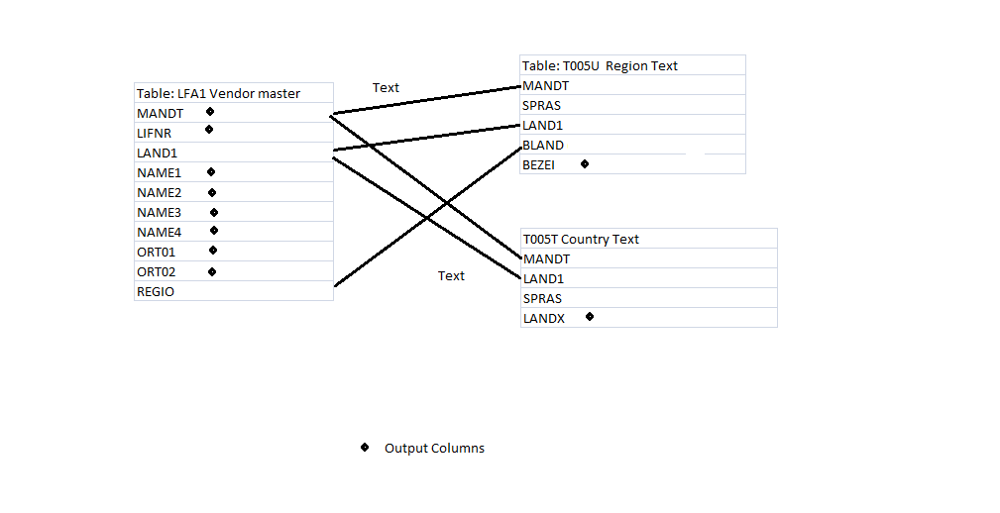

4. Purchasing Group



5. Purchasing Doc. Type



6. Gregorian Time Based Calculation View

Cube Based Calculation View (with star Join):

1. Purchase Order Analysis

Data Foundation level:

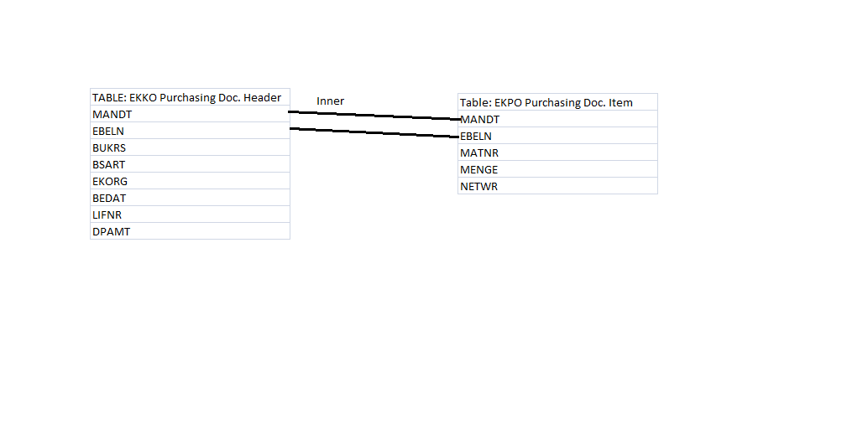

Star join Level:

